Diaphragm Valve
Operation Manual
I. Purpose and Main Performance Parameters
1. Rubber-lined diaphragm valves are suitable for general corrosive fluid pipelines at a working temperature of 65 C or below, serving as a control on/off element.
2. Main performance parameters:

II. Operating Principle and Structural Features
3. This valve is composed of body, bonnet, stem, valve disk, diaphragm, and drive components. The basic structure is shown in Figure 1.
4. The valve is opened and closed by rotating the handwheel. Turning the handwheel clockwise lowers the disk to close the flow path; turning counterclockwise opens the valve.
5. When a diaphragm valve is used on a steam pipeline at a working temperature above 65 C (up to 120 C), the diaphragm shall be made of heat-resistant rubber and this must be specified at the time of order.
III. Maintenance and Installation Precautions
1. Valves shall be stored indoors in a dry and ventilated area. Do not stack valves.
2. Both pipeline openings of stored valves must be sealed to prevent foreign matter from entering the valve interior and damaging the sealing components. Also avoid contact with oil or other flammable materials.
3. Metal machined surfaces shall be cleaned of dirt and coated with anti-rust oil. The grease cup shall be kept topped up with lubricant.
4. Do not apply any grease or oil-based substances to the rubber lining or diaphragm surface, as this will cause rubber swelling and adversely affect valve service life.
5. During storage or shutdown periods, rotate the handwheel counterclockwise to keep the valve in a slightly-open position, so as to avoid the diaphragm losing elasticity from prolonged compression.
6. During transport or installation, slings must not be attached to the handwheel or stem. Also refrain from striking with other metal or hard objects, to prevent damage to components or rubber lining.
7. Before installation, carefully verify that the pipeline operating conditions and medium match the valve's scope of application, so as to avoid inappropriate selection causing losses or even accidents.
8. This valve is not suitable for vacuum pipelines, but may be installed in any position on the pipeline for bi-directional flow. Ensure ease of operation and maintenance.
9. Before installation, flush the valve interior clean to remove any dirt that could jam or damage the sealing components, and check that all connecting bolts are evenly tightened.
10. During operation, regularly inspect the medium-contacting components and replace worn parts according to actual service conditions.
11. When replacing the diaphragm, take care not to tighten it either too much or too loosely.
12. For valves used on intermittent-service pipelines, flush the medium-contacting components during shutdown periods to extend service life.
13. When manually operating the valve, do not use auxiliary levers or tools, so as to avoid excessive torque that could damage drive components or sealing surfaces.
14. Valves that have been repaired must pass a tightness/closure test per applicable standards before being placed back into service.
IV. Possible Faults and Resolutions
Table 1 Possible Faults, Causes, and Resolutions
Possible Fault | Cause | Resolution
Handwheel rotates with difficulty | - Stem fouled or thread damaged  - Stem nut worn or fractured  - Stem bent  - Bearing damaged or cracked | - Clear fouling; dress threads; lubricate  - Replace stem nut  - Replace stem  - Replace bearing
Leakage at valve body and bonnet joint | 1. Uneven tightening of connecting bolts  2. Crack damage of rubber lining layer of valve body | 1. Uniform tightening  2. The valve body shall be replaced
Leakage between sealing surfaces | 1. Dirt accumulated between sealing surfaces  2. Slight damage to sealing surfaces  3. Diaphragm over-tightened or under-tightened  4. Severe corrosion or cracking of diaphragm  5. Crack damage of rubber lining on sealing surfaces | 1. Remove dirt without damaging the sealing surface  2. Refinish according to the original curved surface  3. Properly adjust the tightness of the diaphragm  4. Replace the diaphragm  5. The valve body shall be replaced

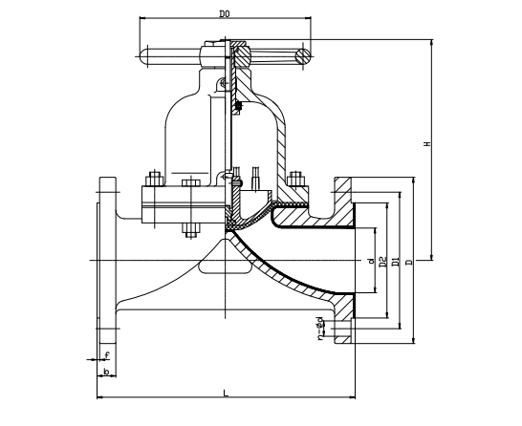
Figure 1 Diaphragm Valve Structure


WEIZIDOM GROUP
www.wsdvalves.com
South City, Longhu Town, Xinzheng City,
Zhengzhou City, Henan Province, China

